A1035-AM,S-Peru-Nazca-Ceramic Goblet-Anthropomorphic Mythical Being with Feline Signifier-Period III- 100-300 CE

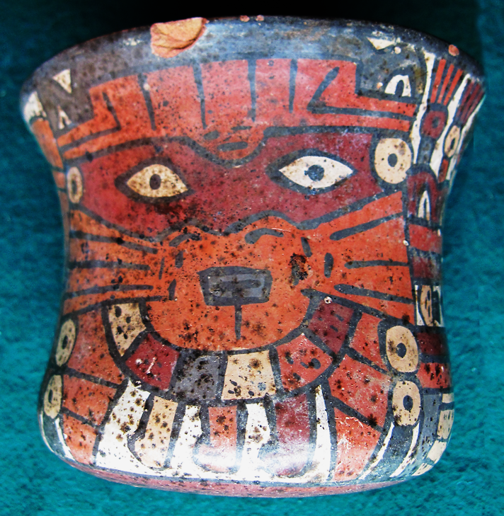 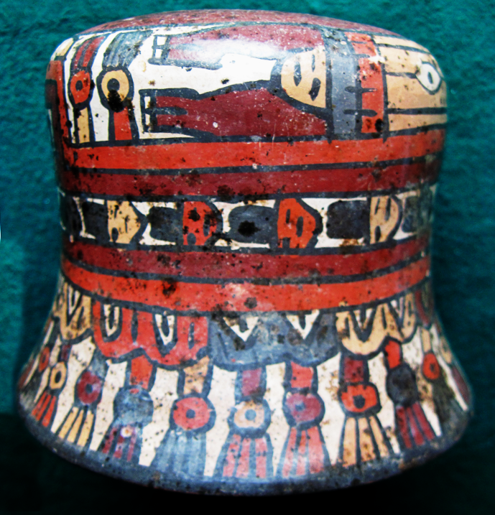

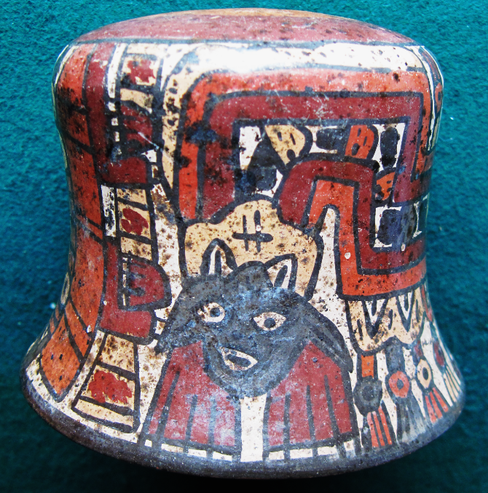 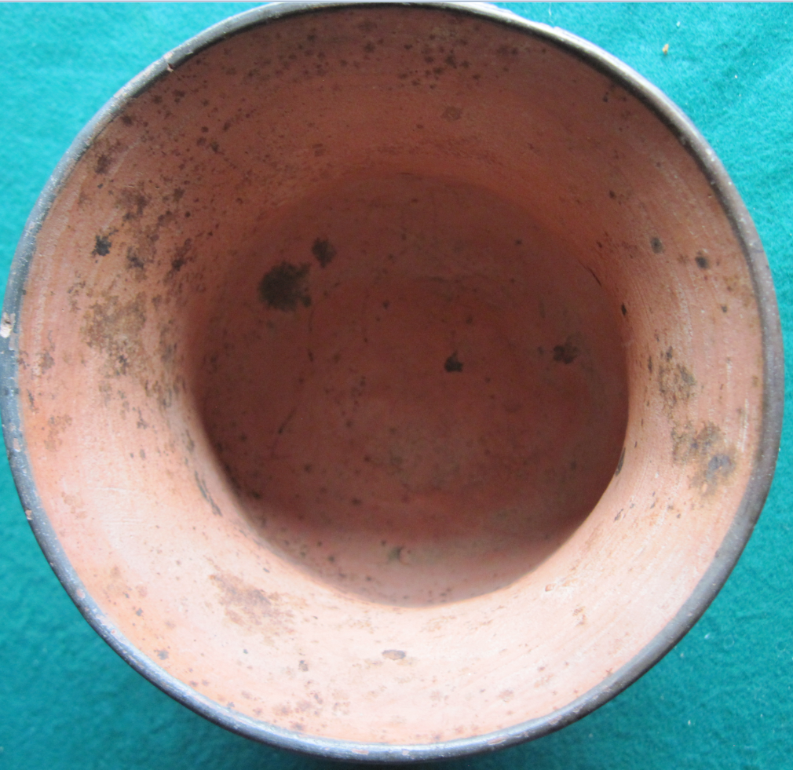

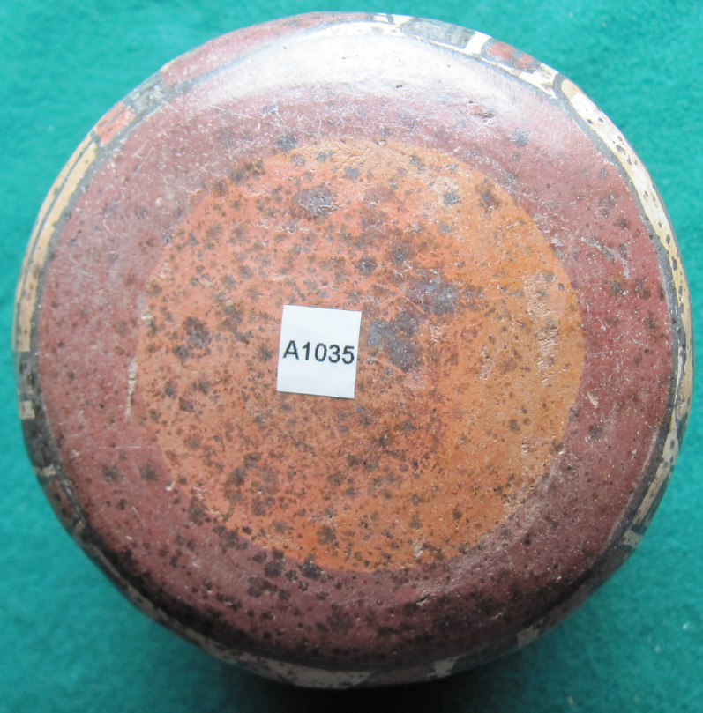

Figs. 1-5. Peru-Nazca-Ceramic Goblet-Anthropomorphic Feline Signifier-Period III- 100-300 CE

**Case no.: 14**

**Accession Number: A1035**

**Formal Label:** Peru-Nazca-Ceramic Goblet-Anthropomorphic Feline Signifier-Period III- 100-300 CE

**Display Description:**

Nazca pottery reveals the spirit world of these ancient people in southern Peru, whose “Anthropomorphic Mythical Being” (Fig. 1) symbolizes a powerful nature spirit that was conjured perhaps under the influence of hallucinogenic drugs (Fig. 1) that may have been consumed from this goblet. The image of the Feline “Anthropomorphic Mythical Being” was probably *not* the mask of a shaman (Proulx 2006: 63) but the Feline mythical Being (AMB-1-A; Proulx 2006: 63),which was probably based on the pampas cat *Felix colocolo*, identified by its border of scalloped edges (Fig. 2) that terminates in a feline head and paws (Fig. 3).

**LC Classification:** [F3429.1.N3](http://library.clevelandart.org/opac/?func=item-global&doc_library=CMA01&doc_number=000067799&year=&volume=&sub_library=CMA)

**Date or Time Horizon:** Period III, 100-300 CE

**Geographical Area:** possibly Cahuachi, Nazca River Valley, southern Peru

**Map, GPS coordinates: -**14.83587 -74.93276;40° 26' 46" N 79° 58' 56" W

**Cultural Affiliation:** Nazca. Period III

**Media:** local clays, some mica, polychrome slip paints.

**Dimensions: H 122.50 mm, 4.82 in;**  Rim 87.83 mm, 3.46 in; Base 93.43 mm, 3.76 in

**Weight: 251 gm; 8 ¾ oz**

**Condition: original, some spalling**

**Provenance:** unknown

**Discussion:**

Nazca potters like their Paracas antecedents formed their ceramics without the use of a potter’s wheel by coiling, drawing and shaping with a paddle and anvil into standardized shapes and iconographies, but they never used a mold as did the Moche. Nazca potters used slip paints as did the Paracas potters with as many as twelve different colors. This Nazca goblet with a constricted mid-section and a flaring rim is of the type classified by Donald Proulx as “J” of a total of 48 standardized varieties (Proulx 2006: 15).

This ceramic, which is a religious object and which may have been involved in the ritual consumption of an hallucinogenic concoction, may have been produced in Cahuachi, a non-urban ceremonial center without a permanent population that developed as the center of a "pilgrimage trade" system in which pilgrims and artists brought together their society’s material expressions of cosmological beliefs through the iconography on ceramics and textiles.

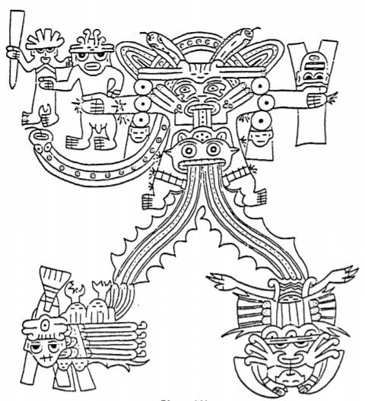

Drawing of the Nazca cosmological concept (from Zuidema 1972: Fig. 5)

Nazca cosmology is represented by "a God or man, standing frontally and dressed in a shirt with a collar, who holds in his right hand two other figures, that forms "an ancestral Underworld triad" (Zuidema 1972: 39), "a cosmological representation of royal power" (Zuidema 1972: 44), of a king and his principal and secondary sons (Zuidema 1972:41). In his left hand he holds an anthropomorphic head (carved on a *huarango* post) who represents the ancestor of the fourth generation depicting conquest. In order to occupy the land, the conquering chief must have in his possession the body of the conquered chief (represented by a trophy head carved on a huarango post) whom he claimed as his own ancestor as the first occupant of the land (Zuidema 1972: 48), a "perpetual kinship" system (cf. Cunnison 1956)

**References:**